**PPiC 7.4** A palindrome is a word that is spelled the same forward and backward, but I also take punctuations into account. I will write a function using *while* loop so that if a word is palindrome, the function return True, if it is not a palindrome, the function will return False.

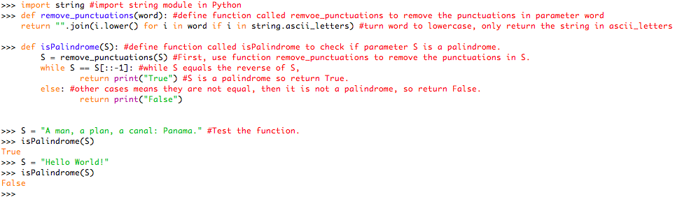

**PPiC 7.5** Load and run the clusterAnalysis function using the exam score data. Compare your clusters with those shown in Session 7.1.

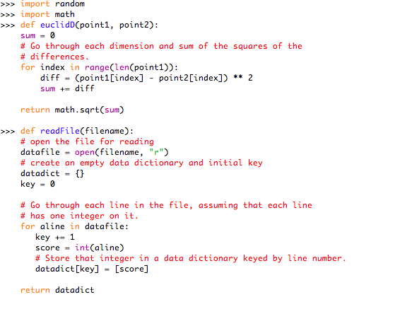

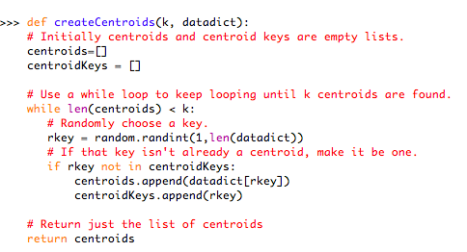

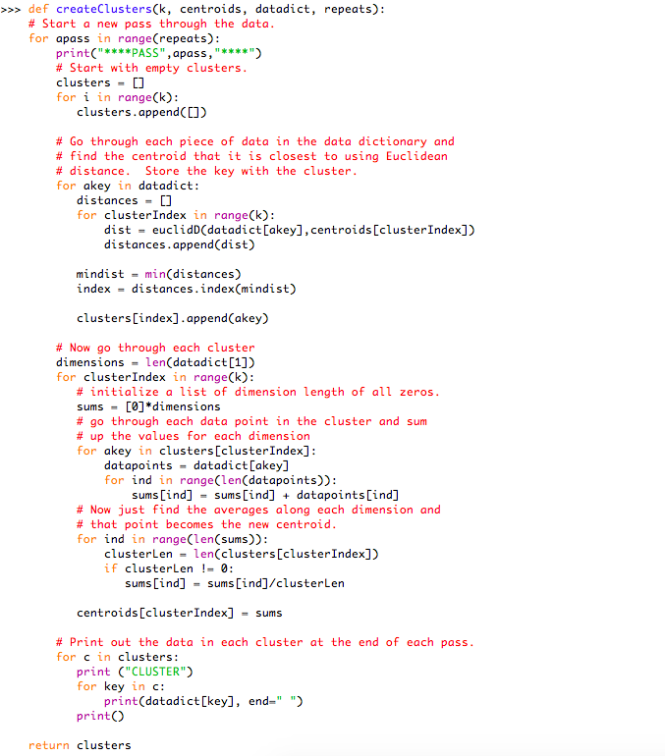

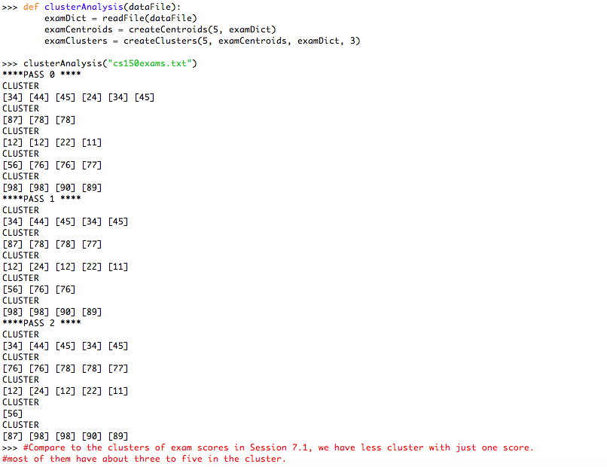

**PPiC 7.6** Run clusterAnalysis again but try to use different numbers of clusters and passes.

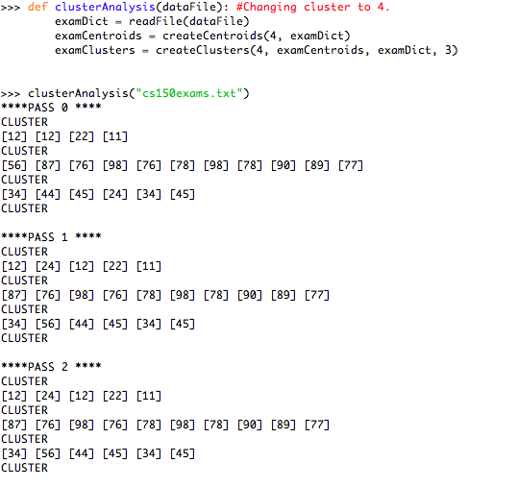

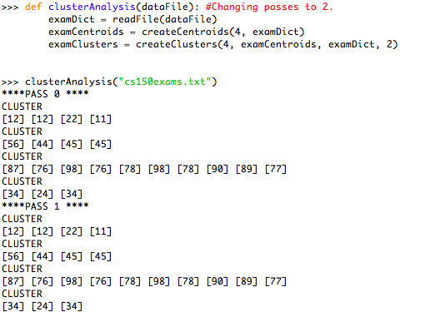

**PS. 5.6.8** Consider the list of characters: ['P','Y','T','H','O','N']. Show how this list is sorted using the following algorithms:

